Target Keyword Cluster: managed farmland near Bangalore | farmland near Maddur | farm plots Mysuru Expressway | quarter-acre farm plots | villa plots near Bangalore | biodiversity by design | organic farmland projects | gated managed farmland community | Vedic forest science | Nakshatra Vana | Navagraha Vana
Featured Thumbnail HTML: <img src="fulfil-your-dream-of-owning-farmland-madhuvana.jpg" alt="managed farmland near Bangalore Mysuru Expressway" />
Secondary Image Alt Tags: alt="farm plots near Maddur Mysuru Expressway" | alt="quarter acre managed farm plot Kaveri river" | alt="Nakshatra Vana Navagraha Vana MadhuVana"
Meta Title: Fulfil Your Dream of Owning Farmland: Managed Farmland Near Bangalore | Vanatvam
Meta Description: Own a quarter-acre managed farm plot at MadhuVana, Vanatvam's farmland near Maddur on the Kaveri — built on Vedic forest science, not monoculture.
URL slug: /blog/fulfil-your-dream-of-owning-a-farmland/ (confirm against live site structure)
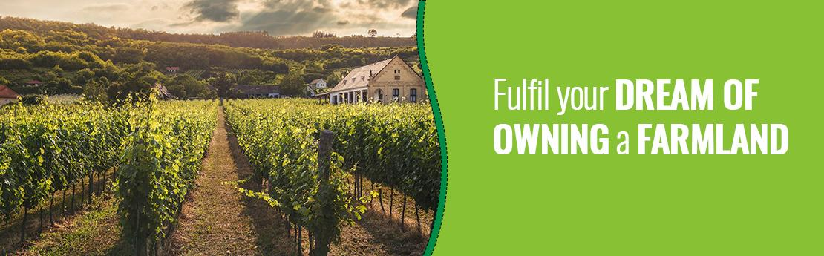

Fulfil Your Dream of Owning a Farmland
These days, owning a farmhouse is the new trend among many families who have been living in major cities. Farmlands in and around Bangalore [<b><a href="/farm-land-for-sale-near-bangalore/">Farmlands in and around Bangalore</a></b>] are gaining momentum. People have realized that it is time to disconnect from the hustle and bustle of city life and discover greener solutions to sustain life on earth. A farmhouse serves as a home to reside in, surrounded by an agricultural farm or a well-landscaped garden. People prefer farmlands or farm properties to experience nature and discover the happiness of a country life.
A perfect dream — our first drawings as kids, a small water stream, a small house surrounded by trees, the sun rising in the backdrop..... Were you one of those people with a dream of owning farmland with a farmhouse? Whether a childhood dream or a recent desire, fulfil and cherish it at MadhuVana, our farmland project set amidst thousands of acres of serene greenery, with the river Cauvery flowing alongside — just like the countryside. MadhuVana sits along the Mysuru Expressway [<b><a href="/madhuvana/">Mysuru Expressway</a></b>], within easy reach of Maddur [<b><a href="/madhuvana/">Maddur</a></b>], in the heart of the Kaveri water belt.
Vanatvam, in partnership with specialist growers and agronomists, is on a mission to develop farmlands based on Vedic Forest science [<b><a href="/">Vedic forest science</a></b>]. The idea is to create sustainable farms not just for humans but for animals and nature too. As ardent believers in Vedic forest science, Vanatvam is incorporating unique features such as Nakshatra Vana [<b><a href="/">Nakshatra Vana</a></b>], Navagraha Vana [<b><a href="/">Navagraha Vana</a></b>] and more, to add a spiritual dimension to raw nature. At Vanatvam farm communities, you can discover, unwind and relax.

What a farm plot truly gives you
Being with nature and enjoying a healthy well-being at farmlands near Bangalore [<b><a href="/farm-land-for-sale-near-bangalore/">farmlands near Bangalore</a></b>] is only part of the story. The deeper value of a Vanatvam farm plot lies in the land itself — the intrinsic worth of the produce it yields, the new skills you discover, and the quiet education of being close to nature. A quarter-acre plot (10,000 sq. ft.) [<b><a href="/madhuvana/">quarter-acre farm plot</a></b>] at MadhuVana gives a family ample room for a food forest, a farmhouse and a life closer to the ground — a different kind of space amidst serene nature than the one villa plots near Bangalore [<b><a href="/">villa plots near Bangalore</a></b>] offer.
A farm planted only with fruit-bearing trees is an incomplete ecosystem. If every tree exists only to yield fruit for human use, who feeds the soil, fixes nitrogen, shelters the pollinators, and sustains the trees themselves? This is why Vanatvam builds every farm community on biodiversity by design [<b><a href="/">biodiversity by design</a></b>] — intentional, mixed-species planting that brings together nitrogen-fixing legumes, deep-rooted native canopies, medicinal herbs and pollinator-friendly flora, so the land becomes a self-sustaining sanctuary rather than a monoculture plot.
A mature tree, left standing, keeps giving back long after it could have been felled for timber — clean air, shade, habitat for birds and insects, and the quiet stabilising presence a young forest needs to take hold. This is the deeper economics of a standing forest, and it is what every organic farmland project [<b><a href="/">organic farmland project</a></b>] at Vanatvam is built around.

Why choose Vanatvam
We believe in remaining custodians of the land we plant. Managing our farm communities for the long term isn't an afterthought for us — it is our primary goal. We exist to conserve and protect the trees we plant, and to see that they grow well; that is the reason Vanatvam was started. We chose not to take the easier route of a CSR-style plantation drive — plant once, and walk away. Instead, we chose a more demanding path: staying present on the land, season after season, taking on the greater effort and the greater responsibility that comes with it. It is a responsibility we take pride in.
Vanatvam works in partnership with specialist growers and agronomists to bring this care into people's lives, reverse the effects of global warming, and foster healthy living alongside modern conveniences. Our farm communities are built and tended by a collective of experienced gardeners, agriculture experts, farmers, environment experts and nature scientists — the people who stay with the land long after it's planted.
Our farm communities are developed with good aesthetics, enhanced with flowers, bees, butterflies and birds. The experience comes alive in the water bodies, the music of the breeze and the rustling of the leaves. When embedded in nature's enormity, feelings and emotions easily coalesce with nature — an ambience that lights up the spirit of life and re-energises you and your family on every visit to MadhuVana. We have built eco friendly cottages [<b><a href="/madhuvana/">eco friendly cottages</a></b>] where you and your family can stay on the farm, or you can choose to build a farmhouse of your own on your dream farm plot.
For more information, visit our site: Vanatvam.com.
Follow us on socials: Instagram, Facebook, X (Twitter), LinkedIn.

Frequently Asked Questions

What does managed farmland actually mean?
Managed farmland brings together private land ownership and collective stewardship. Vanatvam's on-ground team and agronomists care for soil health, irrigation and the surrounding Vanas year-round, so you can enjoy the harvest and the stillness of your farmhouse retreat while experienced hands tend to the land.

What is the minimum plot size at MadhuVana?
Plot configurations at MadhuVana begin at a quarter-acre (10,000 sq. ft.), thoughtfully proportioned to support both a private farmhouse footprint and a thriving mixed-species fruit, flower and native trees based ecosystem.

Can I visit before buying?
Absolutely. Experiencing the soil, the themed Vedic gardens and the atmosphere of MadhuVana firsthand is the best way to feel the difference a biodiversity by design farm community [<b><a href="/madhuvana/">Bio Diversity by design farm community</a></b>] offers. You can schedule a guided walkthrough before making your decision.

Where is MadhuVana located, and how far is it from Bangalore?
MadhuVana is located along the Mysuru Expressway, close to Maddur, about 17kms off the Bangalore Mysore Highway. Madhuvana is interlaced with VC Canal which is fed by river Cauvery. Visit Vanatvam.com for directions, plot availability and site-visit scheduling.
Ready to fulfil your dream of owning a farmland?
Explore MadhuVana [<b><a href="https://vanatvam.com/madhuvana/">managed farmland near Bangalore</a></b>] on our website | Want a quote? Email us at: info@vanatvam.com
Follow us on socials: Facebook | Instagram | X (Twitter) | LinkedIn

